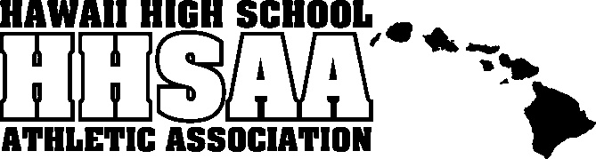
Hawaii High School Athletic Association
----------------------------------------------------------------------------------
 P.O. BOX 62029  HONOLULU, HAWAII 96839 
PHONE: (808) 800-4092
 www.sportshigh.com - info@hhsaa.org 

2017 BILLY TEES / HHSAA BOWLING STATE TOURNAMENT
SOUVENIR T-SHIRT PRE-ORDER FORM

School requests to order the following sizes of the souvenir A4 Drifit T-shirts at $20.00 per shirt.

Size | Quantity | Price | Total
Small |  | $20.00
Medium |  | $20.00
Large |  | $20.00
X-Large |  | $20.00
XX-Large |  | $20.00
 |  | GRAND TOTAL
2017 Bowling Tournament Logo is not available at this time. Check the Bowling page on www.sportshigh.com for updates to the logo.

Email preorders to your respective host (see below) school. Checks payable to HHSAA may be brought to the tournament site of teams first game. Note: preorders must be paid in full by first day of the tournament or shirts will be released to the general public.

Kelii Morgado, Athletic Director

Contact person:

Daytime phone:

Check one:
◻ Check placed in mail on ______
◻ Will drop off at coaches meeting
Kauai High School
E-mail: christian_morgado@notes.k12.hi.us

(Rev.09/27/17)

