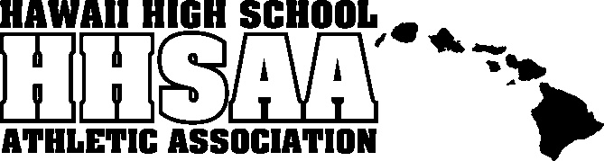
Hawaii High School Athletic Association
----------------------------------------------------------------------------------
 P.O. BOX 62029  HONOLULU, HAWAII 96839 
PHONE: (808) 800-4092
 www.sportshigh.com - info@hhsaa.org 

2017 CIVILIAN MARKSMANSHIP / HHSAA AIR RIFLERY STATE TOURNAMENT SOUVENIR T-SHIRT PRE-ORDER FORM

School requests to order the following sizes of the souvenir Drifit T-shirts at $20.00 per shirt.

Size | Quantity | Price | Total
Small |  | $20.00
Medium |  | $20.00
Large |  | $20.00
X-Large |  | $20.00
XX-Large |  | $20.00
 |  | GRAND TOTAL

Email preorders to your respective host (see below) school. Checks payable to HHSAA may be brought to the tournament site of teams first game. Note: preorders must be paid in full by first day of the tournament or shirts will be released to the general public.

Ryan Hogue, Athletic Director

Contact person:

Daytime phone:

Check one:
◻ Check placed in mail on ______
◻ Will drop off at coaches meeting
Sacred Hearts Academy
Phone: (808) 734-5058
E-mail: rhogue@sacredhearts.org

(Rev. 10/3/17)

